- Internship Name : Data Analysis
- Task Name: Task 9: Handling Missing Values and Removing Duplicates using Pandas
- Your Name : Shubhangi Naresh Khonde
- Internship Organization :
- Date:

1. Objective
To identify missing values (NaN) and duplicate records in a messy dataset, and clean them using the Pandas functions isnull(), fillna(), dropna() and drop_duplicates().

2. Tools Used
- Python 3.13
- Pandas and NumPy libraries
- Visual Studio Code (Jupyter Notebook)

3. Dataset Description
The sample dataset contained 8 rows and 4 columns: Name, Age, City and Salary.
It had the following data quality problems:
- Missing values: Name (1), Age (2), City (1), Salary (1), 5 in total
- Duplicate records: the entries for “Sneha”, “Rahul” and “Amit” were repeated. One “Amit” entry also had an extra trailing space ("amit "), which made it look different from the original.
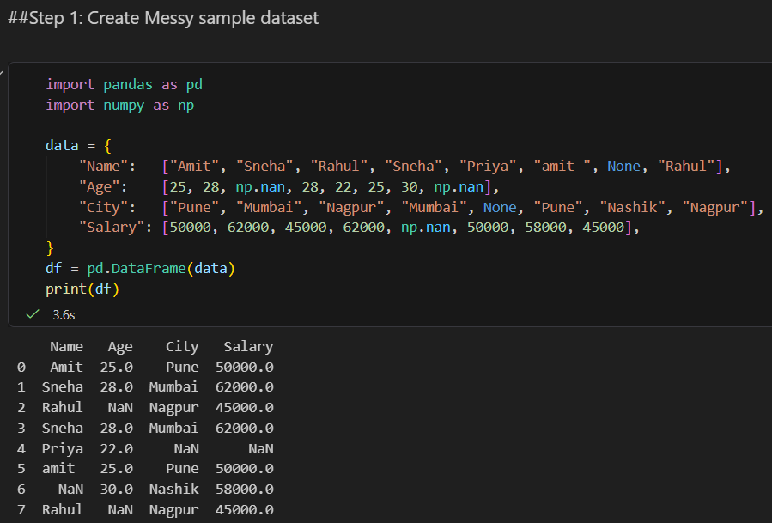
4. Methodology
Step 1: Detecting Missing Values
df.isnull() and df.isnull().sum() were used to find how many values were missing in each column.
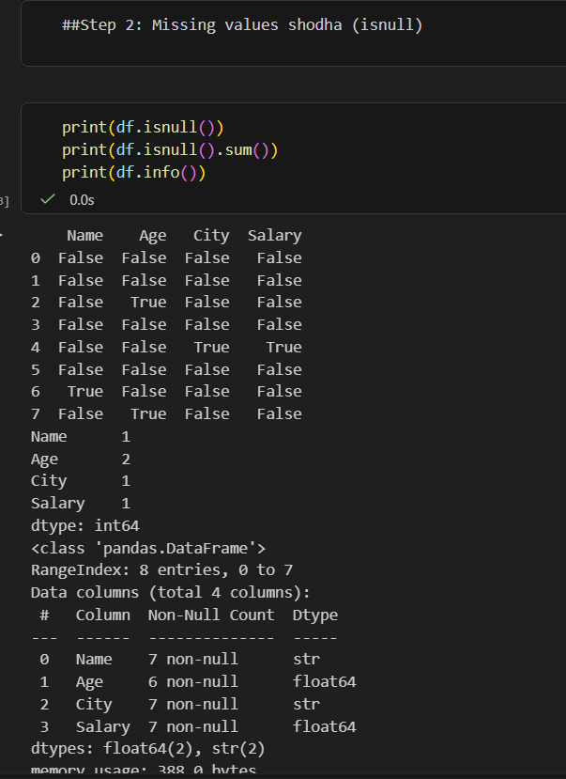
Step 2: Handling Missing Values

Column | Method Used | Reason
Age | fillna(median) | The median is less affected by outliers
Salary | fillna(mean) | The column is numeric, so the average is a suitable replacement
City | fillna("Unknown") | The column is text, so mean or median does not apply
Name | dropna(subset=["Name"]) | Name is the key identifier, and a record without it has no meaning

Step 3: Cleaning Text Data
str.strip().str.title() was applied to the Name column to remove extra spaces and standardize capitalization. Because of this, "amit " and "Amit" were correctly recognized as the same entry.

Step 4: Removing Duplicates
- df.duplicated().sum() counted the duplicate rows (3 were found).
- df.drop_duplicates() removed the duplicate rows.
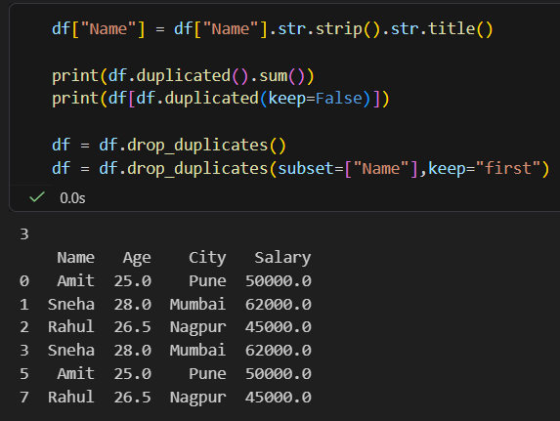

5. Results
Check | Before Cleaning | After Cleaning
Number of rows | 8 | 4
Total missing values | 5 | 0
Duplicate rows | 3 | 0

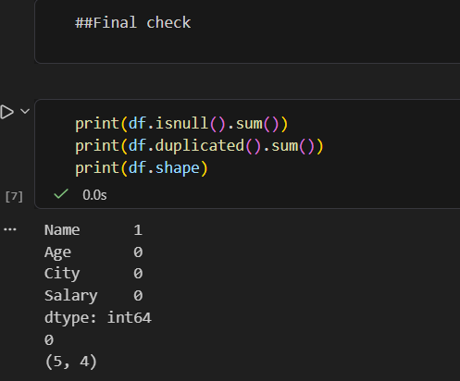
6. Observations
- Without text cleaning, duplicates would have been missed because "Amit" and "amit " look like different values to Pandas.
- fillna() preserved the data by replacing missing values, while dropna() removed records that were unusable because a key column was empty.
- The order of operations matters: missing values and text formatting should be fixed before removing duplicates.

7. Conclusion
The messy dataset was cleaned using isnull(), fillna(), dropna() and drop_duplicates(). The final dataset has no missing values and no duplicate rows, so it is ready for analysis. Data cleaning is a critical first step in any data analysis workflow, because inaccurate data leads to inaccurate results.

